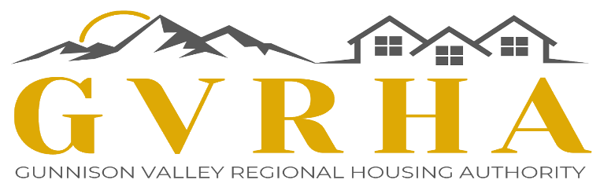

SALE PROCESS – 110B Pitchfork, Mt. Crested Butte
PRICE $205,000
Application packages for persons wanting to be in the lottery for this Lazy S Condo is available on the GVRHA website at www.gvrha.org/homeownershipland-opportunities/.
TIMELINE OF EVENTS
April 9, 2022 Application packages available on GVRHA website
TBD Open House options – Contact listing agent Cindy Ervin, cervin@cbliving.com
970-209-5233 for information on open houses or to schedule a showing!

MAY 13, 2022 Fully completed application packages must be submitted IN HARD COPY ONLY to GVRHA at 202 E. Georgia Avenue in Gunnison. WE CANNOT ACCEPT SCANNED/EMAILED APPLICATION PACKAGES.
MAY 19, 2022 Certificates of Eligibility sent out to qualified applicants.
MAY 27, 2022 Offers to purchase will be accepted by the listing agent ONLY from 9:00 am to 3:00 pm; if more than one offer at the asking price is received, a lottery will be held on May 3rd amongst the offerors to determine which offer is selected.
CONDO INFORMATION
- 1 bedroom, 1 bathroom
- 623 square feet
- HOA dues approximately $400/month, includes:
  - Heat, hot water, electric, water, sewer, gas, cable, internet
- Conveniently located along the Mt. Crested Butte bike path, is on the condo loop bus route and has a beautiful direct view of Mt. Crested Butte.
- Bonus storage unit and assigned parking space
- Home amenities include range, microwave, refrigerator, dishwasher, hook ups for washer/dryer
ELIGIBLE BUYER INFORMATION
- Ownership – natural persons only
- Occupancy – must be your primary residence at all times during your ownership
- Assets – you cannot own any other improved residential real estate at the time of closing
- Residency – must have lived in Gunnison County continuously for the preceding one year prior to closing
- Employment – must earn eighty percent (80%) of the qualifying owner’s income from employment within Gunnison County
- Income - households must be at or below 110% of Gunnison County’s applicable Area Median Income (AMI) as published by HUD and provided to the GVRHA to be eligible to purchase a home
  - 1-person household 110% AMI $66,480 max gross income
  - 2-person household 110% AMI $69,630 max gross income

- Lottery Notice – If more than one offer from qualified applicants is received at the asking price on April 29th, a lottery will be held by the GVRHA on May 3rd for the winner.
OTHER RESTRICTIONS
- Resale – each home will be subject to an appreciation cap upon resale that is the sum of:
  - The initial purchase price, plus
  - 3% per annum (prorated monthly) appreciation on the purchase price, plus
  - The value determined by the purchase price multiplied by the % change in CPI from the date of purchase to date of notification of sale to the GVRHA, plus
  - The value of any special improvement district assessments levied upon the property and paid, plus
  - The value of any capital improvements permitted to be made
NO EXPRESS OR IMPLIED WARRANTY IS GIVEN THAT THE MAXIMUM RESALE PRICE ALLOWED BY THE DEED RESTRICTION WILL BE REALIZED BY THE OWNER IN ANY FUTURE SALE OF THE HOME
- Rentals – owners of these homes may have roommates as long as at least one owner still meets the terms of an eligible owner at all times; an owner must petition the Town prior to vacating the home for three (3) months or longer and prior to renting the home to any qualified occupant
- Short-term rentals – are not allowed at any time for any reason or for any portion of any home, EVER
- Financing – homes may not be purchased with financing that is for more than 100% of the purchase price
- Refinancing – homes may not be refinanced with financing that exceeds 100% of the then-current maximum resale price as permitted by the deed restriction
If you have any questions about these procedures, contact Jennifer at the GVRHA: jkermode@gvrha.org
For more information about the property and the HOA, please contact the listing agent:
Cindy Ervin
Crested Butte Resort Real Estate
Broker Associate
cervin@cbliving.com
970-209-5233

