6725Gunnison Valley – Home Energy Advancement Team (GV-HEAT) Program Intake Form Cover Letter

GV-HEAT is the administrator for four energy efficiency programs operated by state and non-profit entities. Each program has its own qualifications and will receive different levels of support from GV-HEAT. These questions will help GV-HEAT direct participants to the program that best meets their needs.

Program Qualifications

- Energy Smart Colorado (ESC) is run and operated by Energy Smart Colorado. This program is available to all households regardless of income.
- Colorado Affordable Residential Energy (CARE) is run and operated by Energy Outreach Colorado (EOC). This program is available to income-qualified households that earn at or below 80% of the area median income (AMI).
- The Weatherization Assistance Program (WAP) is run and operated by Housing Resources of Western Colorado (HRWC). This program is available to homes that have not been previously weatherized since September 30, 1994 where the household income is at or below 200 percent of the federal poverty level (FPL) or the household has already received financial assistance from one of many federally-funded aid programs.
- USDA Rural Development repair/rehabilitation 504 program (504 Program) is run and operated by the U.S. Department of Agriculture (USDA). This program is available to owner-occupied homes where the household income is at or below 50% of the AMI. At least one occupant must be 62 years of age or older and unable to repay a repair loan.
Figure 1. 2018 income qualifications per GV-HEAT program as gross annual household income
Number of people per household | ESC | CARE | WAP | USDA
One | All | $38,800 | $24,120 | $25,200
Two | All | $44,320 | $32,480 | $28,800
Three | All | $49,840 | $40,840 | $32,400
Four | All | $55,360 | $49,200 | $36,000
Five | All | $59,840 | $57,560 | $38,900
Six | All | $64,240 | $65,920 | $41,800
Seven | All | $68,720 | $74,280 | $44,650
Eight | All | $73,120 | $82,640 | $47,550

GV-HEAT Support and Participant Responsibilities

- ESC: GV-HEAT will help schedule energy assessments and retrofits using GV-HEAT’s dedicated contractor pool and educate households on energy savings tips and utility rebates. GV-HEAT will not provide any funding to ESC participants.
  - Participant responsibilities: Participating households are responsible for 50% of the home energy assessment cost, all retrofit costs, and rebate applications.
- CARE: GV-HEAT will help schedule energy assessments and retrofits using GV-HEAT’s dedicated contractor pool, educate households on energy savings tips and utility rebates, pay for all assessment costs, and cover all retrofit costs (up until a certain amount) after utility rebates have been applied.
  - Participant responsibilities: Participating households are responsible for coordinating with GV-HEAT to schedule home energy assessment and retrofits.
- WAP: GV-HEAT will refer all potential participants to HRWC. GV-HEAT will not provide any funding to HRWC participants. HRWC provides funding up to approximately $7,000 per home.
  - Participant responsibilities: Participating households will coordinate with HRWC to schedule the home energy assessment and retrofits.
- 504 program: GV-HEAT will refer all potential participants to USDA. GV-HEAT will help schedule energy assessments and retrofits using GV-HEAT’s dedicated contractor pool and educate households on energy savings tips and utility rebates. GV-HEAT will not provide any funding to 504 Program participants. USDA provides funding up to approximately $7,500 per home.
  - Participant responsibilities: Participating households will coordinate with GV-HEAT to schedule the home energy assessment and retrofits.

Figure 2. GV-HEAT support services
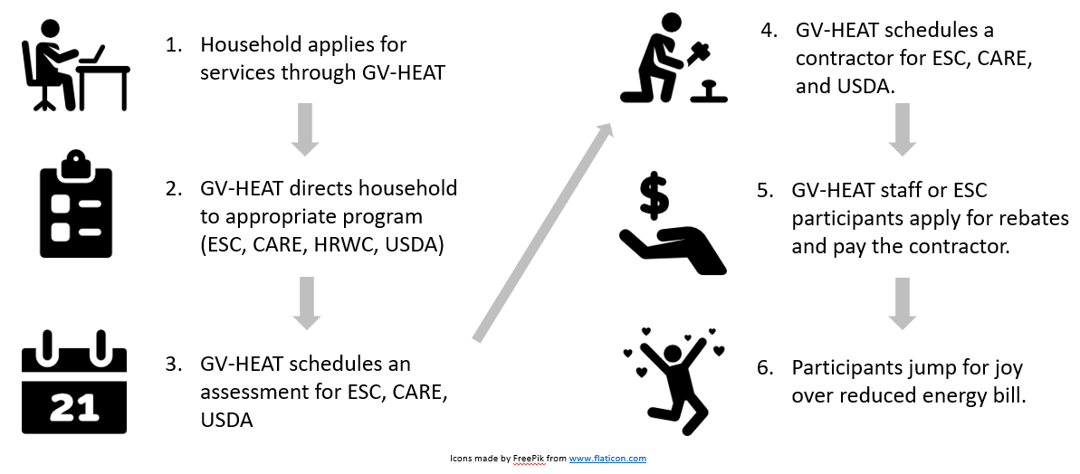

GV-HEAT Confidentiality
GV-HEAT is committed to protecting your personal information and confidentiality. Personal information shared in this application or through your participation in any GV-HEAT associated program will not be shared with other individuals, organizations, or entities without your expressed written consent.

Gunnison Valley – Home Energy Advancement Team (GV-HEAT) Program Intake Form

APPLICANT INFORMATION
Based on your answers to these questions, GV-HEAT staff will direct you to the program that best fits your needs.

Name: ________________________________________________________________________

Address: ______________________________________________________________________

City: _____________________________________ State: ______ Zip Code: ________________

Email: _________________________________________ Phone: _________________________

Driver’s License #: ________________________________ Date of Birth: __________________

Would you be willing to be highlighted as a GV-HEAT program participant? This may include photographs, quotes, and/or a short interview to learn about your experiences with GV-HEAT. We intend to share these stories on our website, Facebook page, and with our program sponsors to support future funding requests.
_______ Yes, I am willing to be highlighted as a GV-HEAT program participant.
_______ No, I would prefer not to be included in any stories about GV-HEAT.

HOUSEHOLD MEMBER INFORMATION
Name | Age | Disabled? | Income | Income Sources

Are any members of the household Native American? (Yes/No)

FINANCIAL INFORMATION
Are you employed?
______Yes
______No

Are you disabled?
_____Yes
_____No

Have you applied for, been denied, or received LEAP funding?
____Yes, I have applied for LEAP funding
____Yes, I have been denied LEAP funding
____Yes, I have received LEAP funding
____No, I have not applied

What is your annual gross household income? _______________________________________

Please include verification in the form of your last 3 pay stubs, W-2, prior year tax return, retirement or SSI benefit letter, or letter from employer

Do you receive household financial assistance from any of the following programs?

____ Temporary Assistance for Needy Families
____ Aid to the Needy and Disabled
____ Old Age Pension
____ Supplemental Security Income
____ Low-Income Energy Assistance Program
____ Supplemental Nutrition Assistance Program
____ Social Security Disability Insurance

UTILITY INFORMATION
Note: Participants must sign and submit an electric and a natural gas utility release waiver prior to program enrollment. Please see attached.

Electricity provider: _____________________________________________________________

Electricity account number/account holder: ______________________________________________________________________________

Natural Gas provider: ____________________________________________________________

Natural Gas account number/account holder: ______________________________________________________________________________

TELL US ABOUT YOUR HOME
Note: If you are unable to answer any of the following questions please write N/A or leave blank.

Type of residence (single-family, duplex, apartment, ranch, mobile home, etc.): ______________________________________________________________________________

Do you own or rent? If you rent, you will be required to submit the attached Landlord Approval Form. _________________________________________________________________________

What type of heating do you use? __________________________________________________

Where is your heating source located (i.e. basement, crawlspace, etc.)? ___________________

What type of cooling system do you use? ____________________________________________

What is the exterior of your house comprised of? _____________________________________

What kind of water heater do you have? ____________________________________________

What kind of cooking appliances do you use? _________________________________________

Has your home been weatherized since 1994? ________________________________________

Are there any additional features of your home that are relevant to share (i.e. fully finished basement, unfinished basement, new roof, crawlspace, etc): __________________________________________________________________________________________________________________________________________________________________________________________________________________________________________

If you own your home, are you likely to sell it in the next 3 to 5 years? ____ Yes ____ No

Are you currently remodeling? ___ Yes ___ No

Does your home have broadband internet access? ____ Yes ____ No

Do any residents of the home use oxygen tanks? ____ Yes ____ No

Do any residents of the home have severe allergies to dust, fiberglass, latex, or other building materials? ____Yes ____ No

Have you already installed a project that you are interested in obtaining rebates for?
____ Yes ____ No

If yes, tell us about the project:
__________________________________________________________________________________________________________________________________________________________________________________________________________________________________________
Do you have invoices from the contractor, or proof of payment for DIY work? ____ Yes ____No

Release of Liability:
I understand that that completion of this intake form does not guarantee that home repair and efficiency services will be provided at a discounted rate nor does GV-HEAT guarantee a level of savings in energy bills. Further, I release GV-HEAT from any liability that may result from conducting home energy assessments and retrofits.

Name: ______________________________________________________________________
Signature: ___________________________________________________________________
Date: _______________________________________________________________________

ATTACHMENTS:
Utility Release Forms
Income Verification (last 3 pay stubs, W-2, prior year tax return, retirement or SSI benefit letter, or letter from employer)

